Logrus TMX Editor 2.0
Key Features:
- Create and edit TMX files containing up to 8 separate languages;
- Work with all language pairs simultaneously in a tabular form;
- Search and filter segments according to different criteria (regular expression search conditions are not yet supported)
- Select and highlight different segments, or groups of segments;
- Block or protect segments from editing and deletion;
- A system of checks, including widely used quality assurance;
- A different editing window for more comfortable work with a specific language in a segment;
- A flexible system of segment selection for exporting;
- Remove HTML, XML, and RTF tags;
- Export selected segments to TMX or XLIFF (v1.2) file formats;
- Split the TMX file into several smaller files;
- Export arbitrarily selected language pairs from a TMX file (export format).
System requirements: Windows x64, .NET 4.5, 4GB+ RAM.
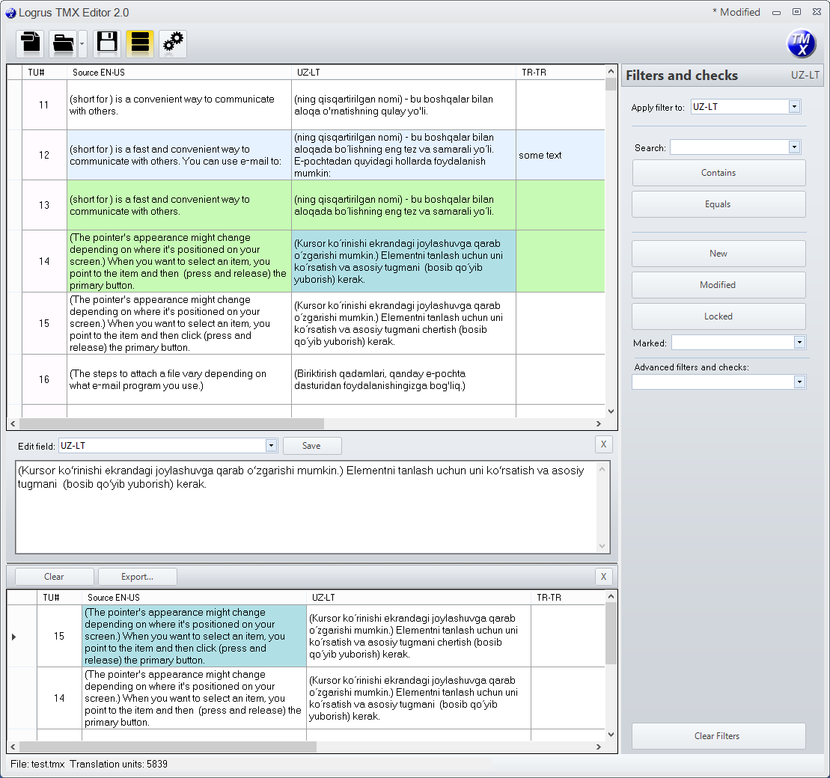

User interface functionality:
The main menu is represented by the following icons:
- create a TMX file
- open a TMX file
- show a list of previously opened files
- show filters and checks tab
- show and add languages to the TMX file

Most editing features are accessible from the contextual menu (Right-click) table or by hot-key;
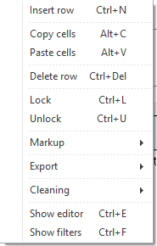

Insert row – create a new unit (row) in the current file view
Copy cells – copy selected cell contents to the clipboard
Paste cells – insert to the table from clipboard
Delete row – delete selected units
Lock / Unlock – lock (protect) and unlock units from deletion or editing
Markup – mark and isolate line groups with individual colors for a more convenient working file
Export – copy or move selected units into a temporary table for further manipulation and exportation to other files
Cleaning – remove various artifacts from cell contents
Show editor – show the editor tab for more convenient work with the desired language inside the unit
Show filters – show filters tab
TMX file creation
When creating a new TMX file, you must specify the language pairs contained.
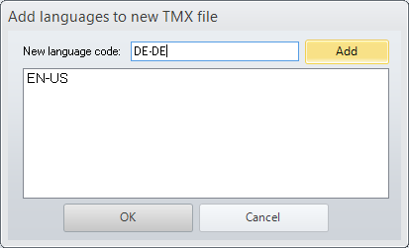
The addition of new languages to the current file works similarly, through this menu 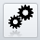
Furthermore, the contextual menu ‘Insert row’ (or Ctrl+N) allows the addition of further rows. Figure below shows the new file table alongside the editor (Ctrl+E).
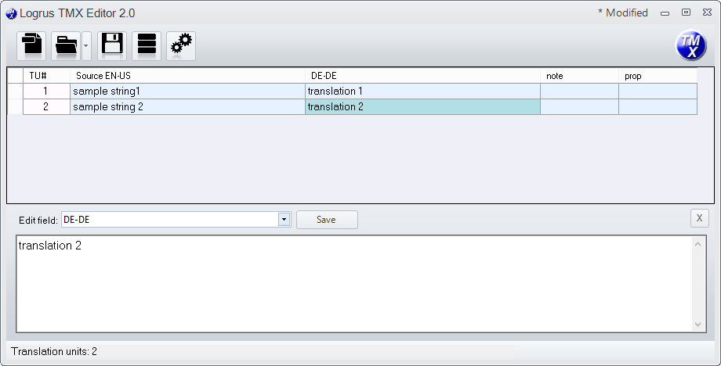

Working with filters and checks
To open the Filters and checks tab, open the Show Filters (Ctrl+F) in the contextual menu, or click
In the drop-down menu, “Apply filter to”, you must select the language which will be subject to the search and check operations.
Searching is conducted by:
- “contains” or “equals” condition
- unit status: new, altered, blocked
- by color markup: filter out those rows which have been marked in some way
Core LQA checks are accessible through the drop-down list "Advanced filters and checks". After checking the table, lines that meet the criteria will be filtered in.
- Source = Target – the source text and translation target (selected language) are the same
- Capitalization – capitalization check
- Leading and trailing spaces – checks the presence and number of spaces at the beginning and the end of the source text and translation
- Double spaces – checks for double spaces
- Digits and numbers – compares the presence and amount of numbers
- Placeholders – checks placeholders such as {0}, %s, %d, %1 and etc.
- Balanced pairs – checks delimiter pairs such as () [] {} <> <!- -->
- Punctuation – compares punctuation at the begging and end of the segment
- Relative size – searches for segments in which the difference between the length of the source text and the translation differs by > 60%
- Empty segments – searches for empty segments
- Partially translated – partially translated segments in which the outgoing translation is not very different from the source
- Find duplicates – search for duplicates. Unlike other tests, this test will not compare the source and translation, and instead will search for duplicates in the selected language from the 'Apply filters' tab.
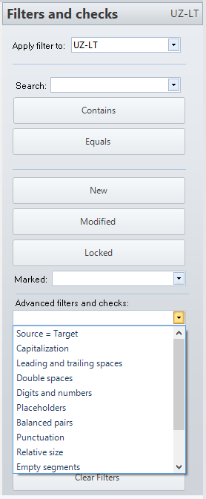
Cleaning translations within units from artifacts
Tags only – removal of all tags like <anytag> </anytag>
Tags and text – removal of all text and tags between the tags: “<anytag>text2del</anytag>”
Tags like { } –removal of RTF tags
Trim first and last spaces – removal of spaces at the beginning and end of the segment 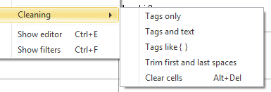

Resource exportation to other files
The selection of units for export is done via the context menu, Export. Scroll to a group of units (segments), and click Copy to storage or Move to storage - units will be copied or moved to a new table, respectively.
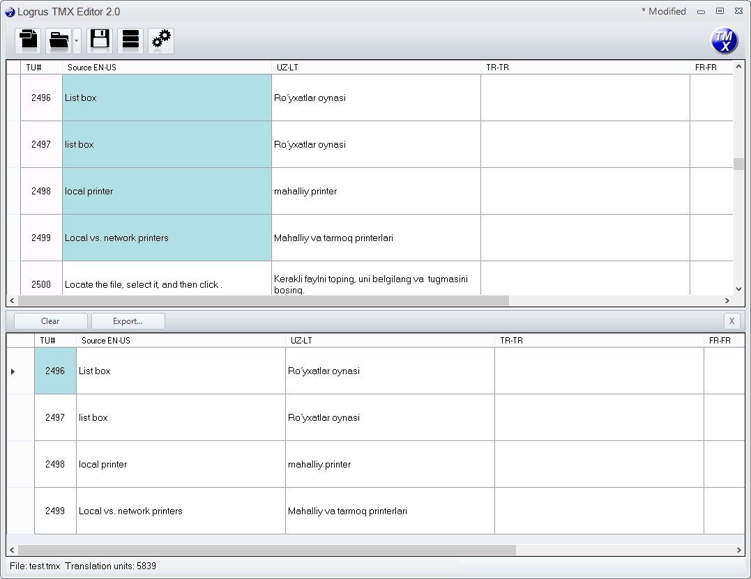
Then, when you press Export, you will be prompted to name the exported file, depending on the final format:
For TMX – select the language pairs for the new TMX file:
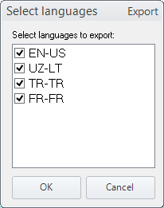
For XLIFF – single language pair selection:
